
(College / School / Department): College of Natural Sciences, School of Biological Sciences
RISK ASSESSMENT TITLE: Use of Cancer Laboratory

Location / Building / Area: | Brambell Building, Cancer and Drosophila Laboratories (Rooms 401 / 402 / 404 / 424) |  |  |  | Activity (Summary): | General use of the Cancer Laboratory by staff and students. This assessment does not cover the use of hazardous substances or equipment not listed below. Additional assessments may be required as indicated on this Risk Assessment Form.
Date of Assessment: | 15th October 2009 |  |  |  | Name of Assessor: | John Latchford / Suzanne Barnes
What are the dangers/hazards? |  |  | Who might be harmed and how? | What are you already doing to prevent harm? |  |  |  | What further action is necessary? |  |  | Action by whom
Slips / Trips and Falls |  |  | Staff and students | - Floor in good condition  - Bags and coats stored in lockers  - Power leads properly sited to avoid trip hazards  - Adequate storage is provided  - Academic Supervisor regularly undertakes inspections |  |  |  | - All spillages to be reported immediately and cleared in accordance with Information Sheet CS5 - Emergency Spill Procedure  - Ongoing monitoring undertaken |  |  | Staff and students
Electrical Hazards |  |  | Staff and students | - All equipment PAT Tested  - User checks carried out – see Information Sheet LS2 - Electrical Safety |  |  |  | - All defects to be reported to Technical Staff immediately |  |  | Staff and students
Personal Contamination |  |  | Staff and students | - Lab coats worn at all times  - Suitable footwear worn  - Hair tied back  - Appropriate PPE eg gloves worn as directed by COSHH Assessments undertaken  - Good laboratory practices implemented  - No eating, drinking or application or cosmetics allowed in Lab  - Laboratory benches sanitized after use  - Hands washed in designated sink regularly and prior to leaving Laboratory |  |  |  | - All suspected contamination to be reported immediately to Supervisor. Do not leave the laboratory until authorised to do so  - Lab coats regularly laundered by specialist contractor |  |  | Staff and students
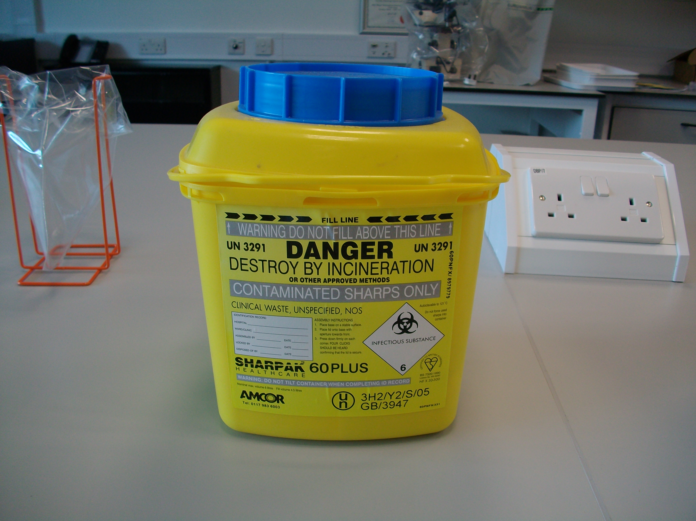  Sharps eg needles, scalpels and broken glass |  |  | Staff and students | - Care taken when using scalpels, especially when changing blades  - All sharps disposed of in sharps container  - All breakages reported immediately |  |  |  | - Sharps containers to be closed when full and disposed of promptly via specialist Waste Contractor  - Broken glass to be disposed of in designated bins  - All sharps injuries must be reported |  |  | Staff and students
Manual Handling |  |  | Staff and students | - Team lifting for heavy items  - Equipment stored appropriately eg heavy items and glassware stored below shoulder height  - Appropriate access equipment used |  |  |  | - Identify need for manual handling training and risk assessment and provide if required |  |  | H&S Officer
Emergency Procedures eg fire and first aid |  |  | Staff and students | - All personnel receive H&S Induction before working in Laboratory  - ‘Action to Take’ signs displayed in laboratory  - Appropriate fire fighting equipment eg extinguishers provided  - Regular fire drills undertaken  - PEEPs undertaken where required |  |  |  | - Check first aid provision  - Ensure staff and students aware of 333 number |  |  | H&S Officer
Spills of Hazardous Substances |  |  | Staff and students | - Spills cleared promptly  - Appropriate equipment provided eg spill kits  - Materials used to clean spills placed in specific bins and disposed of by Specialist Waste Contractor |  |  |  | - All spillages to be reported immediately and cleared in accordance with Information Sheet CS5 - Emergency Spill Procedure  - Ensure all laboratory users are aware of location and how to use chemical spill kits |  |  | Staff and students  H&S Officer
Exposure to Hazardous Substances – chemical and biological |  |  | Staff and students | - Reference to specific COSHH Assessments as required |  |  |  | - Ensure specific COSHH Assessments are undertaken for the use of all hazardous agents  - Ensure safe storage of all chemicals see Information Sheet CS3 - Chemical Storage |  |  | Academic  Supervisors  Laboratory Manager
General and Chemical Storage – contact with falling objects, exposure to hazardous substances, fire and explosion |  |  | Staff and students | - Heavy items never stored above shoulder height  - Full glass vessels never stored above shoulder height  - Steps provided to reach items stored at height  - Chemicals stored in accordance with Information Sheet CS3 - Chemical Storage and relevant COSHH Assessments |  |  |  | - Ongoing monitoring undertaken |  |  | Staff and students
Alcohol Flaming (sterilization of glass spreaders etc) – burns from naked flame and burning alcohol, risk of fire |  |  | Staff and students | - Reference to specific COSHH Assessments as required  - Activity restricted to trained personnel  - Minimal volumes of alcohol used  - Alcohol is used in a glass container placed on a metal bunding tray  - Work area kept free of all combustible materials |  |  |  | - Ensure spreading rod is cool before placing in to alcohol  - Ensure that a flame proof lid or wet towel is available prior to commencing work  - If alcohol is container is accidentally ignited DO NOT attempt to extinguish with water. Cover the container with a fireproof lid / wet towel  - If the fire does not extinguish promptly or spreads sound the Fire Alarm and evacuate |  |  | Staff and students
Fire |  |  | Staff, students and the Emergency Services | - Flammable chemicals and activities kept to a minimum  - Local fire fighting equipment provided  - Combustible materials kept to a minimum  - Good level of fire safety awareness amongst staff  - Fire alarm system installed  - Fire drills regularly undertaken  - Fire and smoke detection within the building  - Liaison with Emergency Services regarding building fire risk takes place |  |  |  | - Undertake specific Risk Assessment if a process may introduce a heightened fire risk |  |  | Staff and students
EQUIPMENT SAFETY – refer to ‘Electrical Hazards’ above
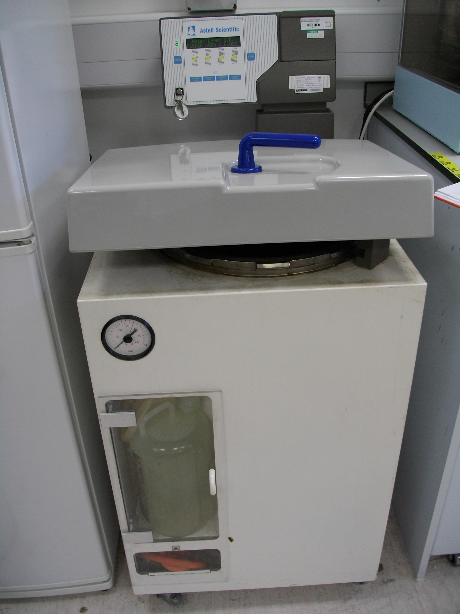  Autoclaves – burns, manual handling, chemical and biological hazards |  | Staff and students |  | - Use restricted to authorized trained personnel  - Autoclave operated in accordance with Information Sheet LS4 – Safe Use of Autoclaves  - Reference to specific COSHH Assessments as required  - Item regularly inspected for electrical safety |  |  |  | - Autoclave to be serviced annually  - Ensure details of autoclave notified to Insurers  - All defects to be reported immediately to Laboratory Manager  - Vessel to be inspected according to Pressure Systems Safety Regulations 2000 |  |  | Chief Technician  Insurance Officer  H&S Officer  Staff and students
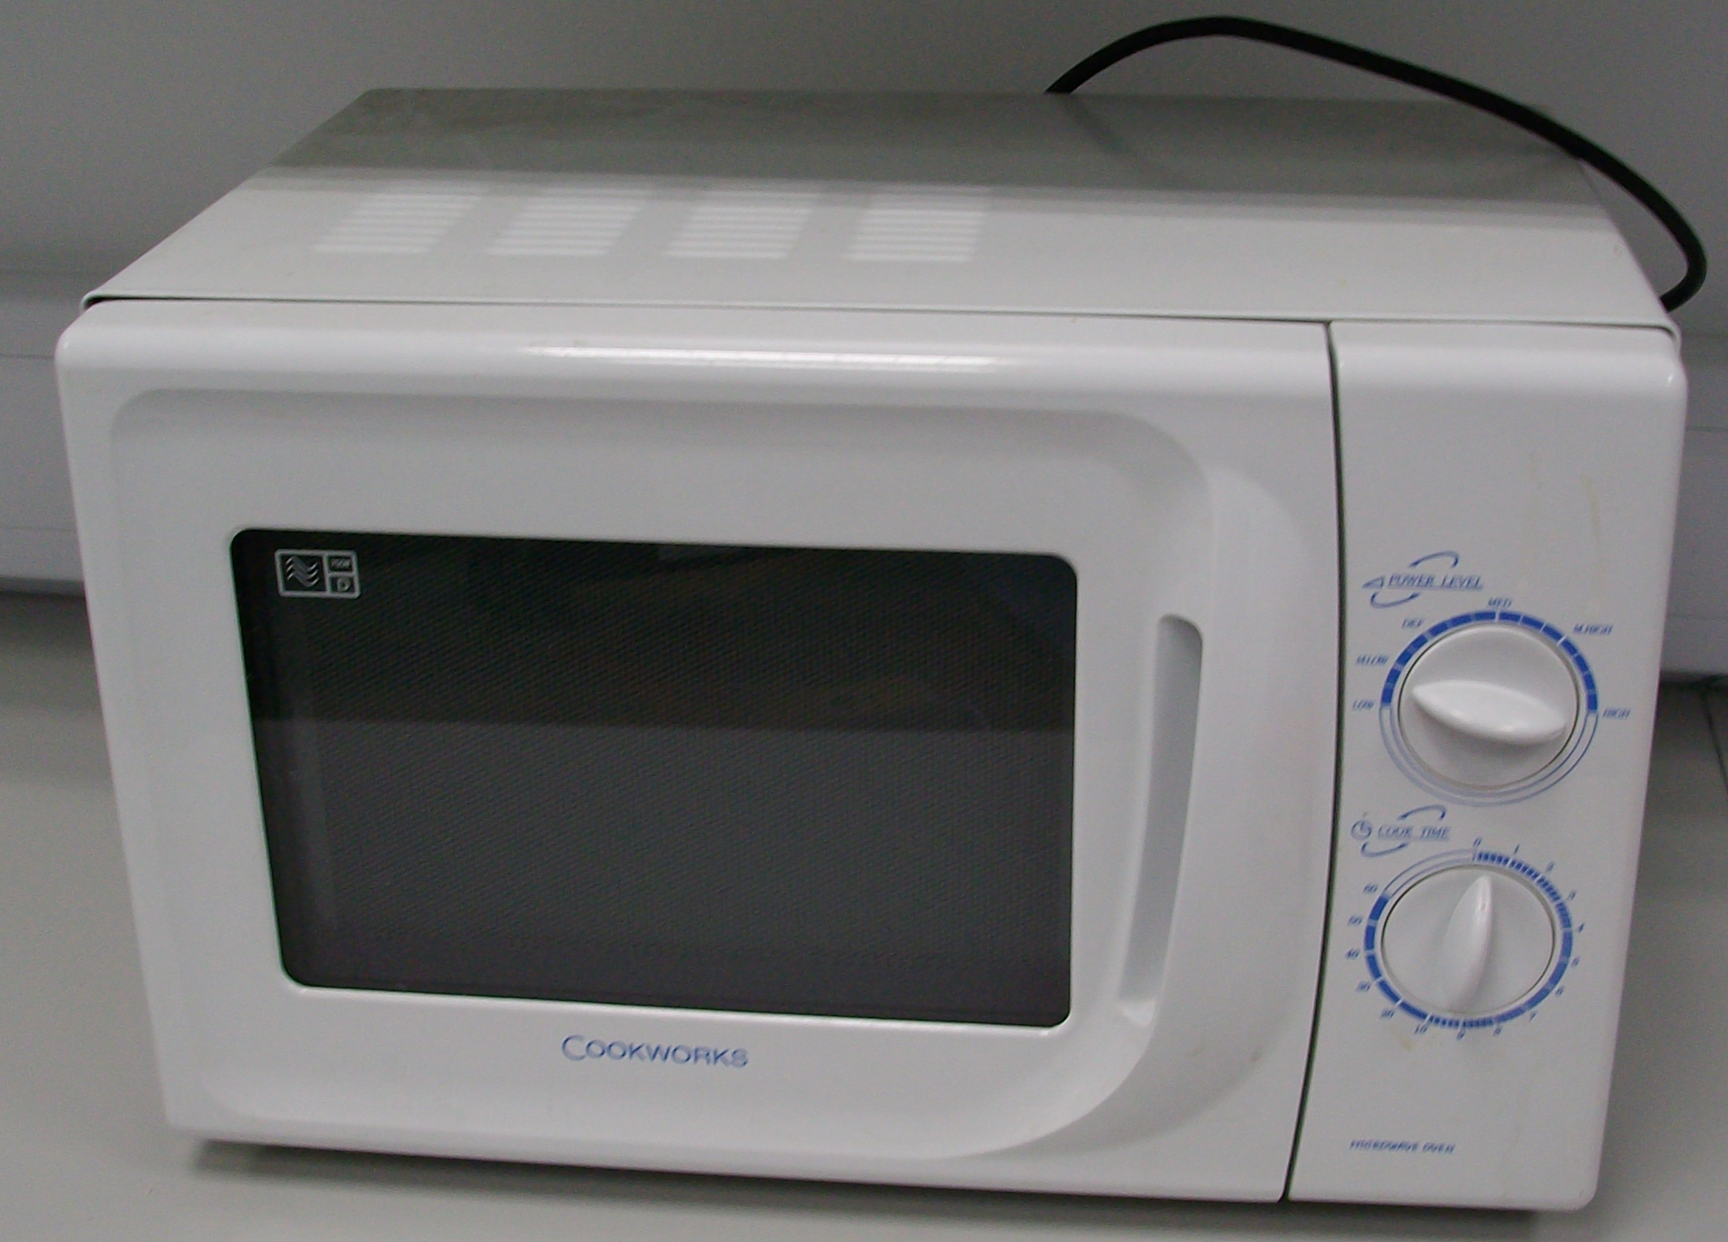  Microwave Oven – burns, chemical and biological hazards |  | Staff and students |  | - Microwave operated in accordance with Information Sheet LS3 – Safe Use of Microwaves  - Reference to specific COSHH Assessments as required |  |  |  | - All defects to be reported immediately to Laboratory Manager |  |  | Staff and students
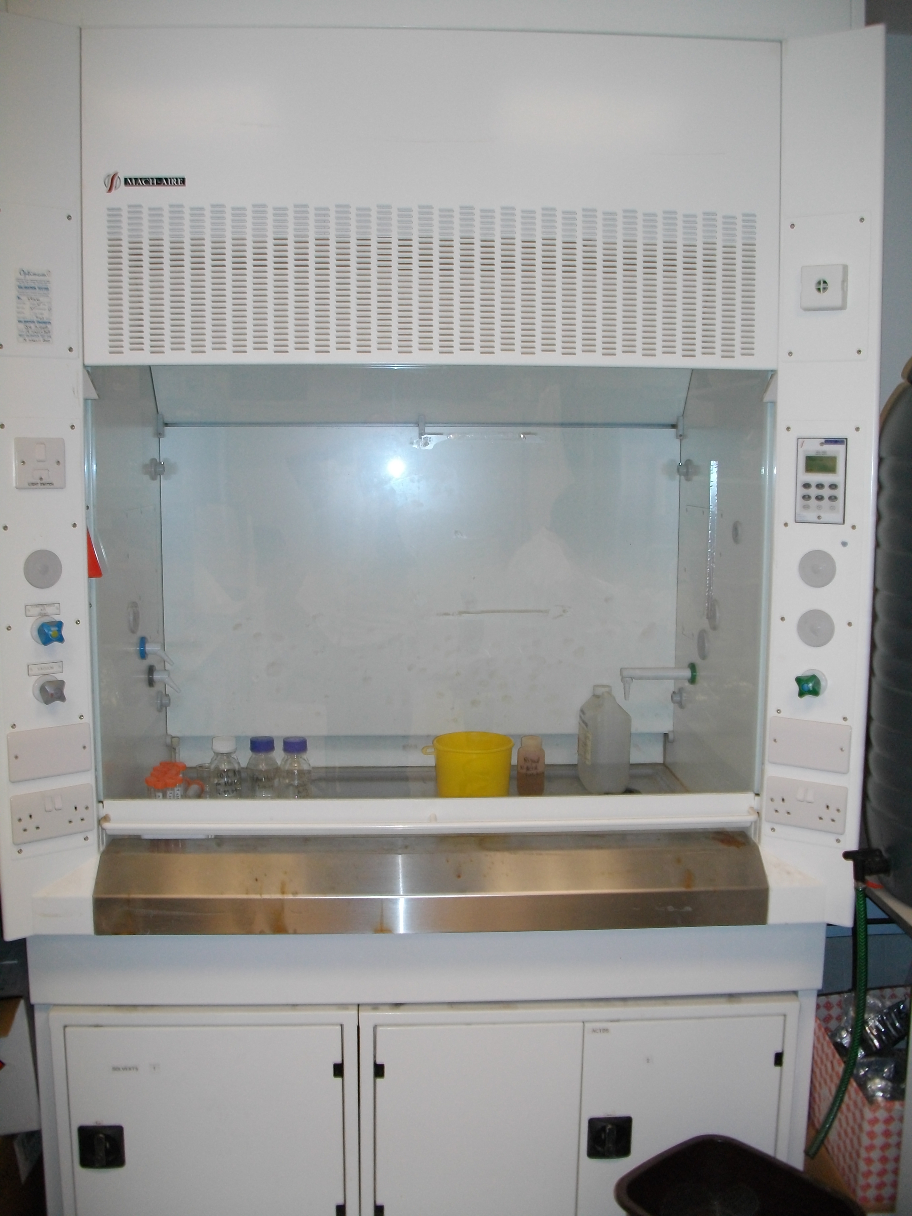  Fumehoods – potential exposure to hazardous vapours, gases and particulates and fire |  | Staff and students |  | - Fumehood operated in accordance with Information Sheet LS6 – Safe Use of Fume Hoods  - Reference to specific COSHH Assessments as required |  |  |  | - Fume hoods to be tested annually  - All defects to be reported immediately to Laboratory Manager |  |  | Estates  Staff and students
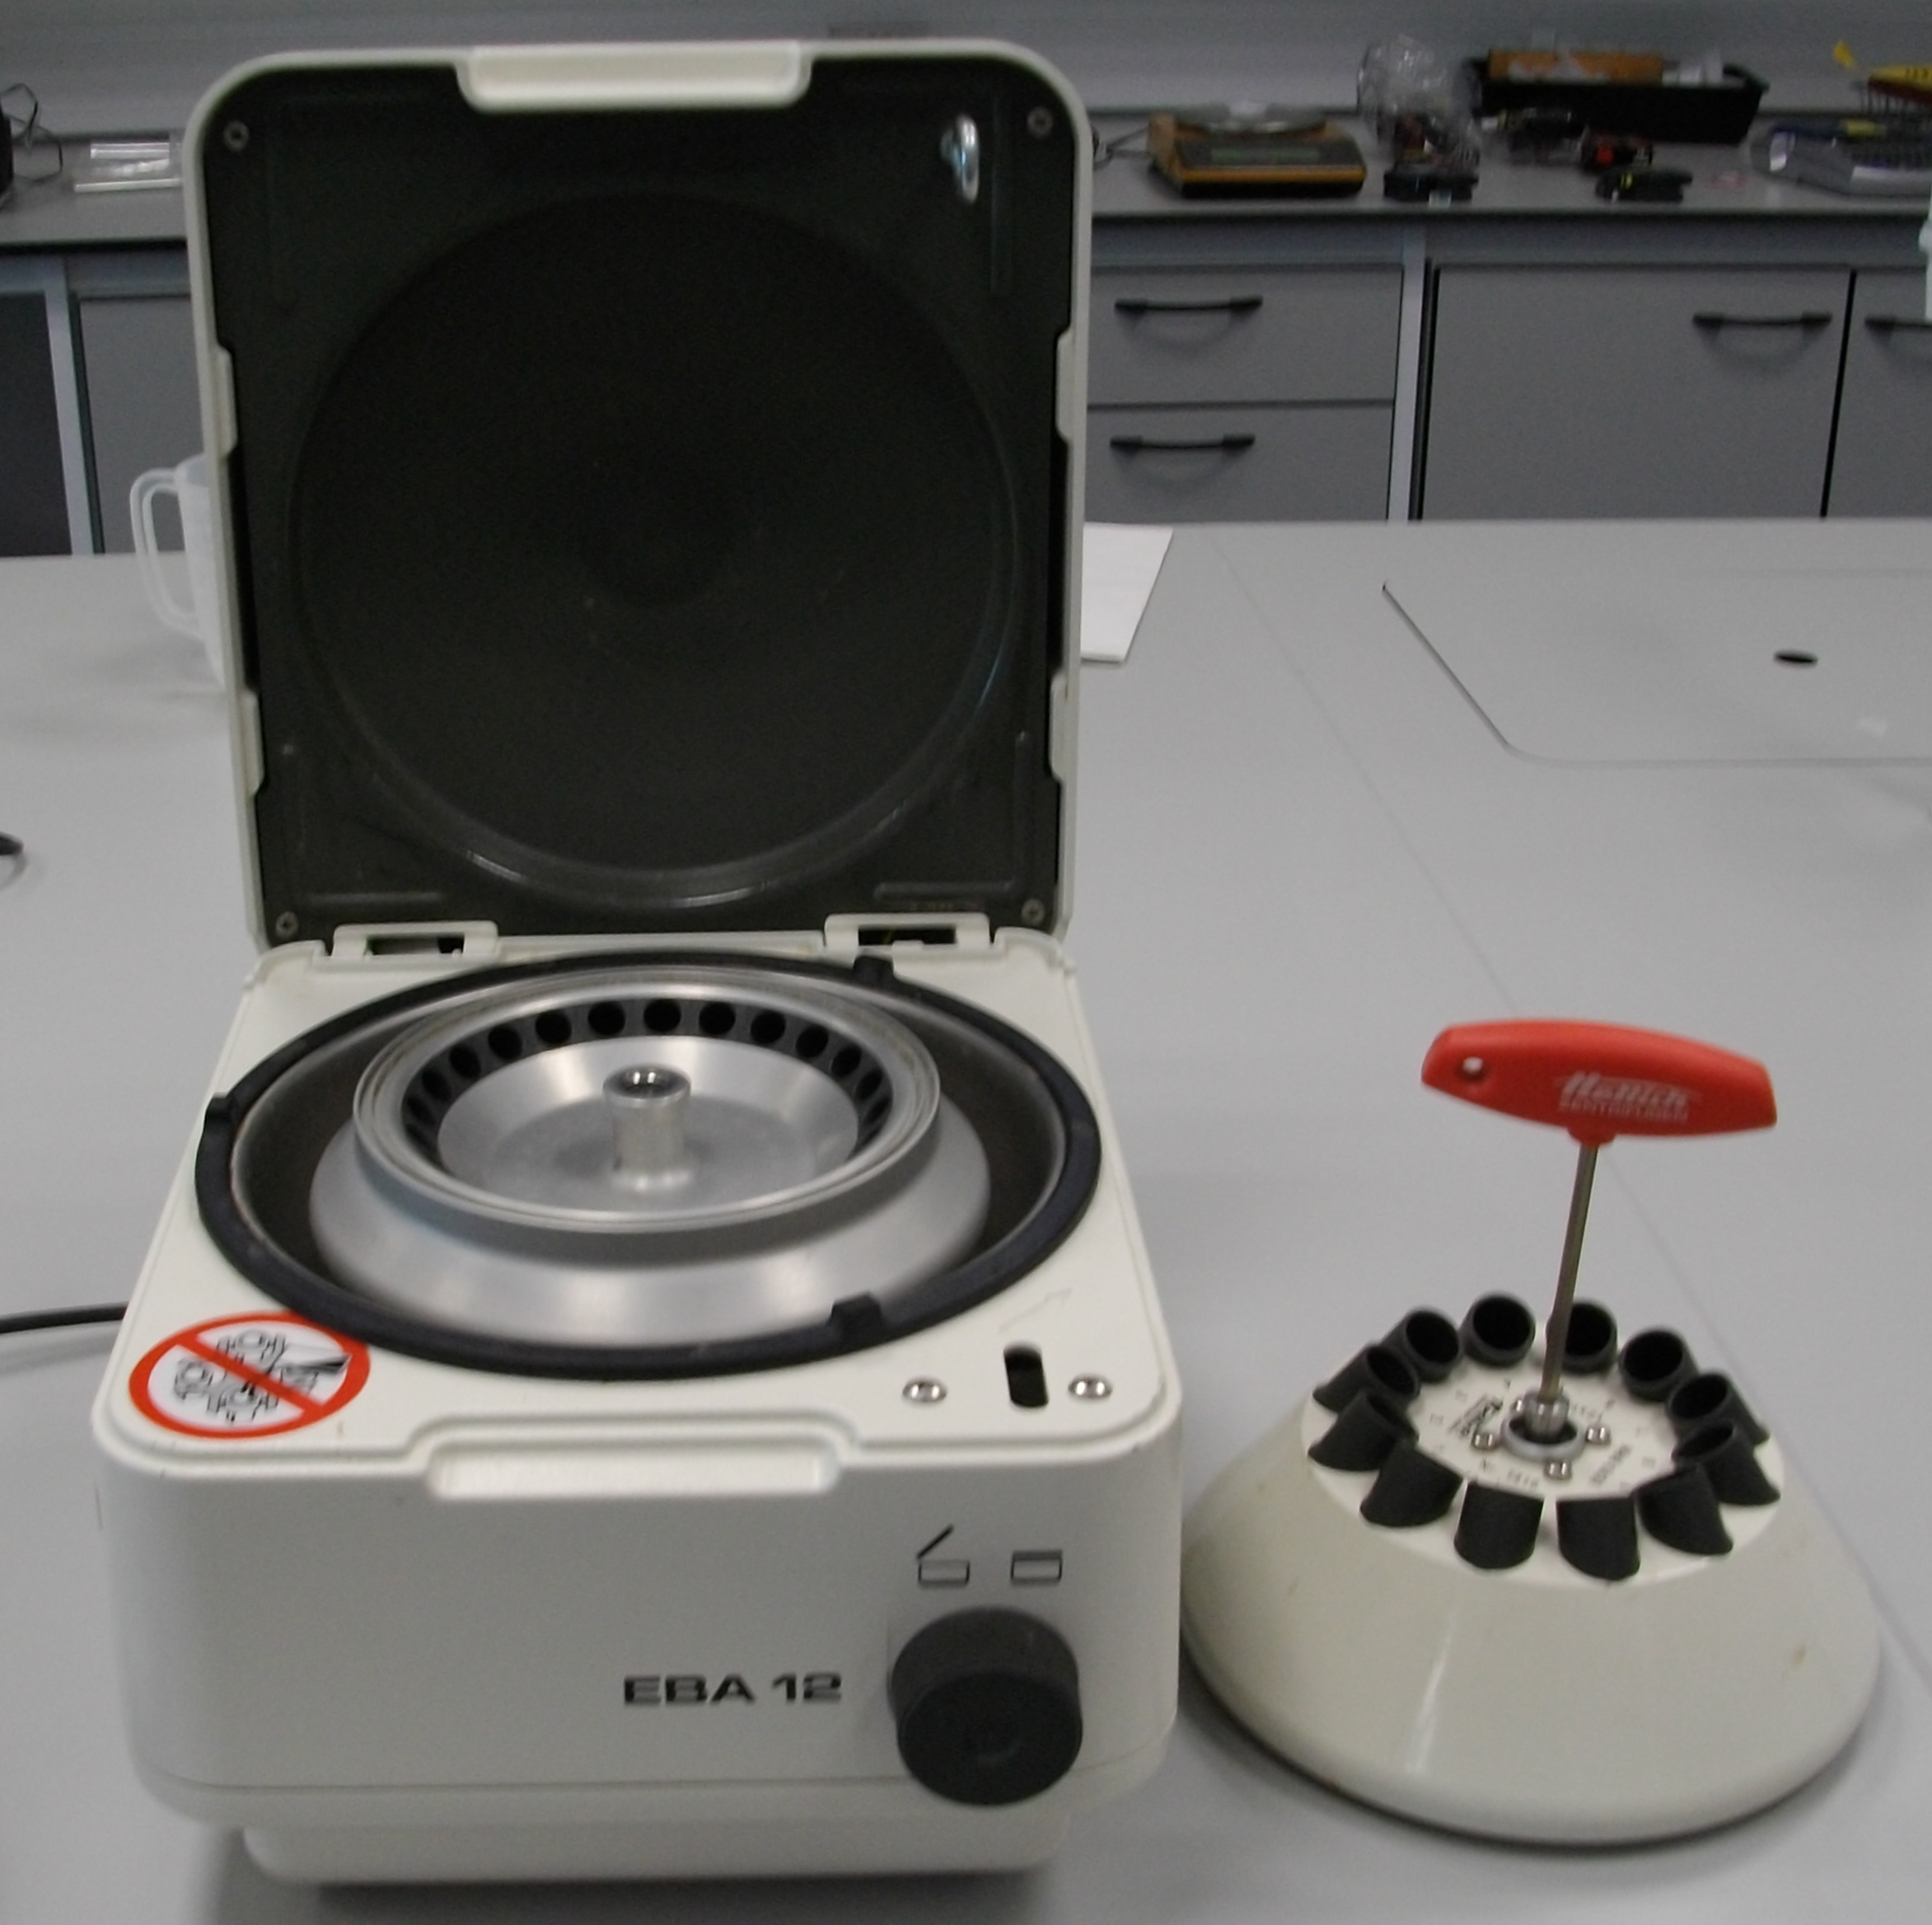  Micro and Midi Centrifuges – mechanical injuries, chemical and biological hazards |  | Staff and students |  | - Micro Centrifuge operated in accordance with Information Sheet LS5 – Safe Use of Micro Centrifuges  - Reference to specific COSHH Assessments as required |  |  |  | - All defects to be reported immediately to Laboratory Manager |  |  | Staff and students
Use of high speed and floor standing centrifuges - mechanical injuries, chemical and biological hazards, property damage, fire |  | Staff and students |  | - Operators trained and supervised until competent to operate alone  - Centrifuge operated in accordance with Information Sheet - Safe Use of High Speed and Floor Standing Centrifuges  - Reference to specific COSHH Assessments as required |  |  |  | - List of authorized operators to be displayed  - Centrifuge to be serviced annually |  |  | Lab Manager  Chief Technician
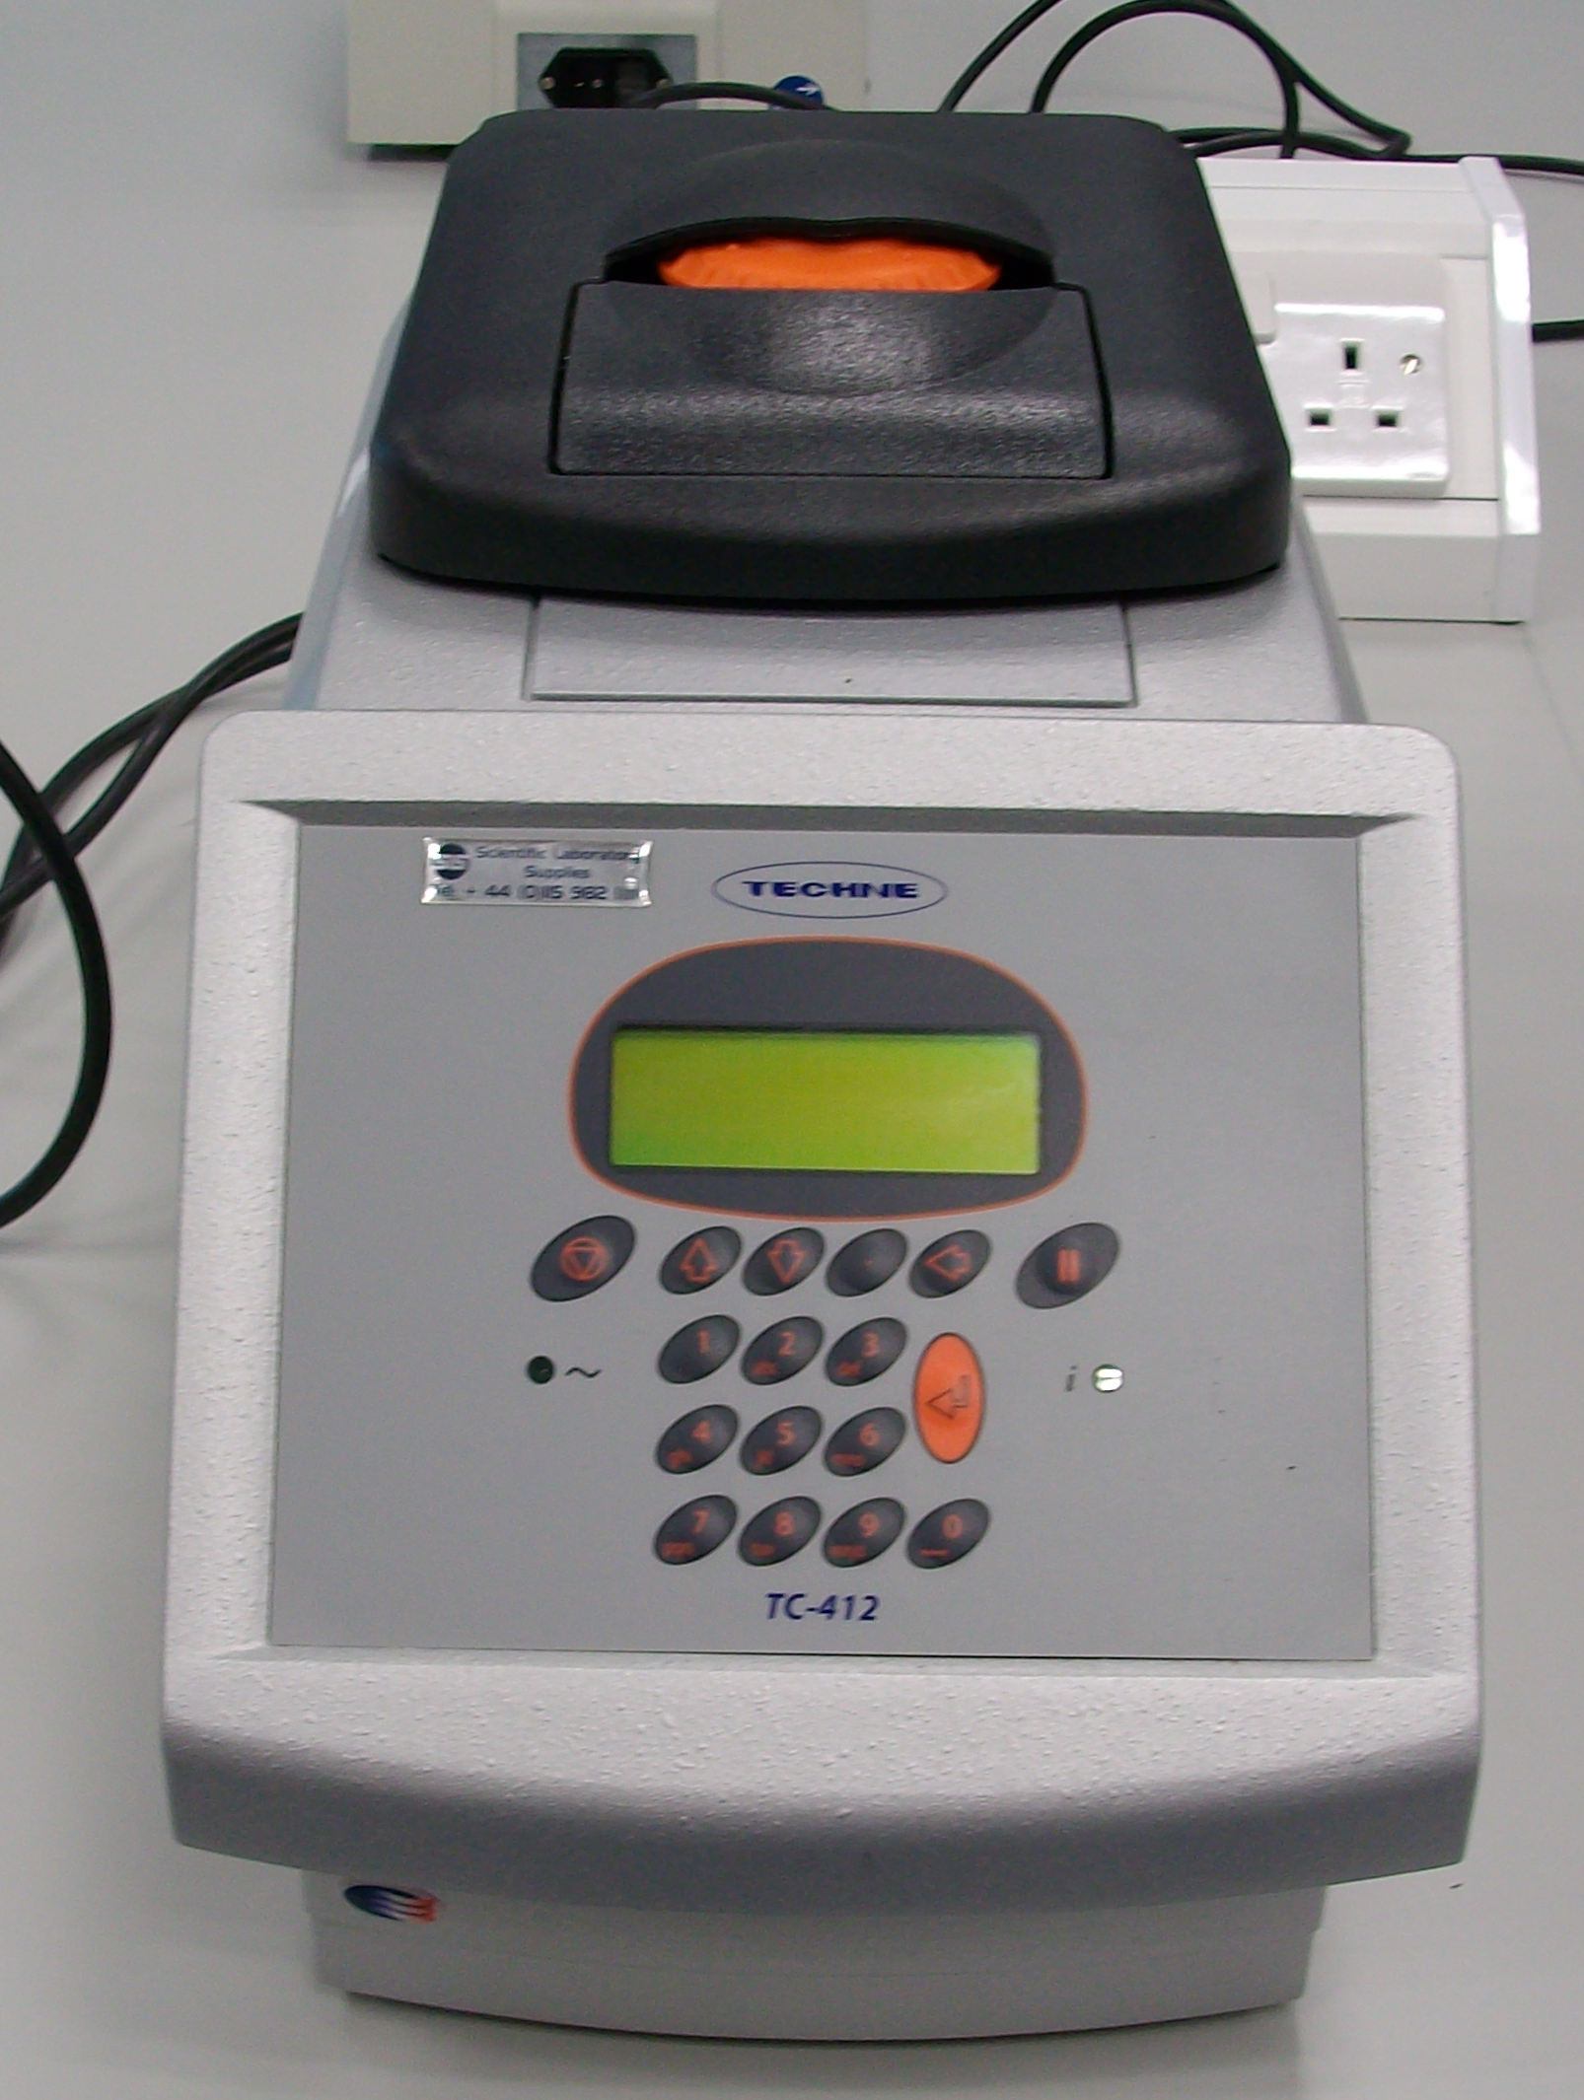  PCR Machine – exposure to hazardous substances and burns |  | Staff and students |  | - Reference to specific COSHH Assessments as required  - Care taken – not to touch hot parts of machine  - Warning notices displayed |  |  |  | - All defects to be reported immediately to Laboratory Manager |  |  | Staff and students
Microscopes – frequent prolonged use can lead to eye strain, headaches and upper limb disorders. Risk of exposure to hazardous substances |  | Staff and students |  | - Users trained in the correct set up and use of microscopes  - Height adjustable chairs supplied  - Reference to specific COSHH Assessments as required  - Regular breaks taken |  |  |  | - If liquid spilt on microscope isolate power immediately and notify Laboratory Manager  - All defects to be reported immediately to Laboratory Manager  - Consider use of monitor if microscope is to be used regularly for extensive periods of time |  |  | Staff and students
Heating Blocks and Hot Plates – burns, contact with sharps if containers break, fire if incorrect container used or substances heated inappropriately, exposure to hazardous substances |  | Staff and students |  | - Warning notices displayed  - Care taken to avoid hot parts of machinery  - Heat resistant gloves worn as appropriate  - Reference to specific COSHH Assessments as required  - Appropriate heat and chemical resistant containers used  - Materials not left unattended on hot plate |  |  |  | - If a spillage occurs, isolate power immediately and notify Laboratory Manager  - All defects to be reported immediately to Laboratory Manager  - Ensure equipment is electrically isolated after use |  |  | Staff and students
Hybrigene Oven - burns, contact with sharps if containers break, exposure to hazardous substances |  | Staff and students |  | - Warning notices displayed  - Care taken to avoid hot parts of machinery  - Heat resistant gloves worn as appropriate  - Reference to specific COSHH Assessments as required |  |  |  | - Turn off oven at electrical socket before cleaning spillages |  |  | Staff and students
Balances and Ph Meters – exposure to hazardous substances |  | Staff and students |  | - Reference to specific COSHH Assessments as required  - Balances cleaned after use |  |  |  | - If liquid is spilt on a balance, isolate power immediately and notify Laboratory Manager  - All defects to be reported immediately to Laboratory Manager |  |  | Staff and students
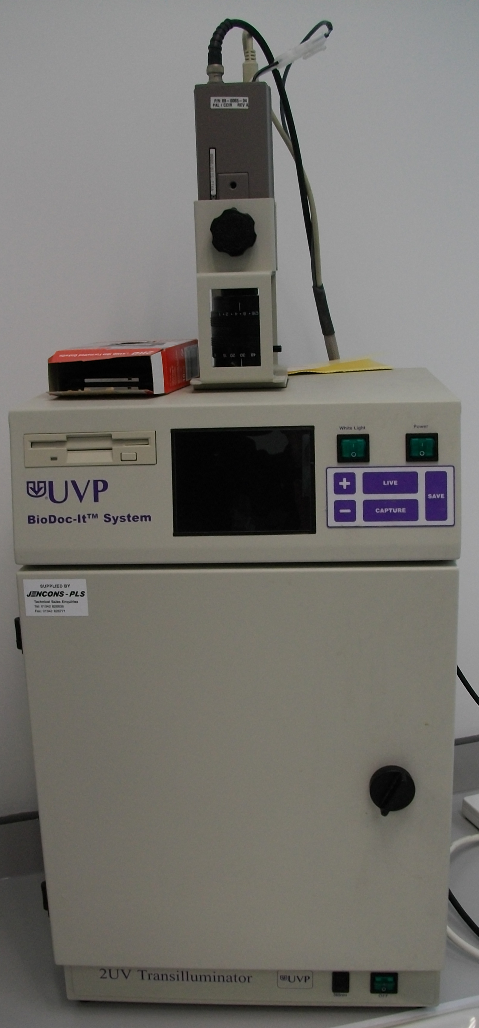  UVP Illuminator – burns to skin and eyes from UV light, exposure to ethidium bromide |  | Staff and students |  | - Reference to specific COSHH Assessment for ethidium bromide  - UV light source interlocked with operation of the door  - NItrile gloves worn when handling gels containing ethidium bromide |  |  |  | - Interlock to be checked by Laboratory Manager regularly  - All defects to be reported to Laboratory Manager |  |  | Laboratory Manager  Staff and students
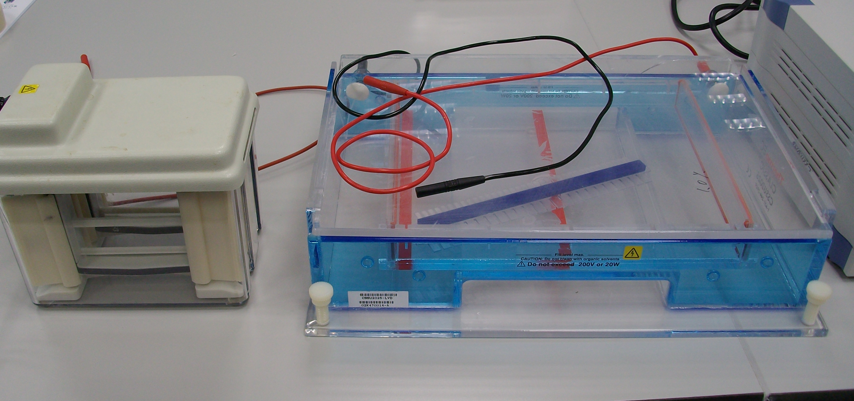  Electrophoresis equipment and power supplies – electric shock and exposure to hazardous chemicals, particularly ethidium bromide when handling agarose gel electrophoresis equipment |  | Staff and students |  | - Reference to specific COSHH Assessments as required  - Nitrile gloves worn when handling agarose gel electrophoresis equipment  - Gel tanks examined for cracks, leaks, exposed wires  - Gel tank lid firmly closed before switching on the electrical supply |  |  |  | - If leaks occur during electrophoresis isolate equipment immediately and inform Laboratory Manager |  |  | Staff and students
Drying cabinet – contact with hot surfaces, electrical hazards |  | Staff and students |  | - Heat resistant gloves worn if required  - Excess water removed from equipment before placed in drying cabinet |  |  |  | - Ensure items are not placed on top of cabinet to avoid blocking the vents |  |  | Staff and students
Fridges / Freezers (general) – exposure to hazardous substances, contact with sharps eg broken glass |  | Staff and students |  | - Reference to specific COSHH Assessments as required  - Suitable leak proof containers used |  |  |  | - Ensure containers labeled with date, substance, owner and hazard information  - Fridges cleaned and de-frosted as required |  |  | Staff and students
Ultra Low Temperature Freezers – severe cold burns, exposure to hazardous substances, contact with sharps eg broken glass |  | Staff and students |  | - Reference to specific COSHH Assessments as required  - Suitable leak proof containers resistant to very low temperatures used  - Cold resistant gloves always worn |  |  |  | - Check cold resistant gloves are available and in good condition  - Ensure containers labeled with date, substance, owner and hazard information |  |  | Laboratory Manager  Staff and students
Biological Safety Cabinet – exposure to hazardous substances |  | Staff and students |  | - Operators trained and supervised until competent to work alone  - Reference to specific COSHH Assessments as required  - Hood sanitized after use  - Appropriate PPE worn  - Airflow checked before use  - Cabinet maintained and certified |  |  |  | - Waste to be disposed of appropriately and promptly  - List of authorized operators to be displayed  - Hood to be inspected every 12 months according to COSHH Regulations |  |  | Staff and students  Laboratory Manager
Water baths – exposure to hazardous substances, hot surfaces and water, potential legionella risk |  | Staff and students |  | - Reference to specific COSHH Assessments as required  - Heat resistant gloves worn if required |  |  |  | - Water baths to be emptied weekly or heated to 60ºC for one hour every month |  |  | Laboratory Manager
Genie Disruptor – creation of aerosols leading to exposure of hazardous substances |  | Staff and students |  | - Screw cap tubes always used  - Lids secured before use
Shaking Incubators – exposure to hazardous substances, electrical shock, potential exposure to sharps eg broken glass |  | Staff and students |  | - Reference to specific COSHH Assessments as required  - Appropriate containers used, not overfilled and firmly secured |  |  |  | - Ensure containers labeled with date, substance, owner and hazard information  - Always clean up breakages and spills promptly. Refer to specific COSHH Assessment to ensure the clean up is undertaken safely. Contact Laboratory Manager of Supervisor if unsure  - Always turn off incubator at electrical wall socket before cleaning up spillages and breakages |  |  | Staff and students
Liquid Nitrogen – risk of asphyxiation, severe tissue burns, manual handling |  | Staff and students |  | - Liquid nitrogen used in accordance with Health and Safety Services Guidance Note – OHSU G25 Guidance on the Handling, Storage and Transportation of Liquid Nitrogen |  |  |  | - Ensure liquid nitrogen pressure vessels are notified to Bangor University Insurance Officer |  |  | H&S Officer
CO₂ Cylinders (Compressed Gases) – manual handling, asphyxiation, potential burns, injuries arising from contact with falling cylinders or during uncontrolled gas release when cylinders could act as projectiles |  | Staff and students |  | - Only trained personnel handle cylinders or change regulators  - Gas cylinders used in accordance with Information Sheet LS8 – Safe Use of Laboratory Gas Cylinders |  |  |  | - List of authorized personnel to be displayed  - Installed gas alarms to be checked regularly |  |  | Laboratory Manager
CL1000 UV Crosslinker – exposure to hazardous substances, potential for UV burns |  | Staff and students |  | - Only trained personnel operate equipment  - Reference to specific COSHH Assessments as required  - Interlocking devices protect against exposure to UV  - Appropriate PPE worn |  |  |  | - Proper functioning of interlock to be checked regularly |  |  | Laboratory Manager
Labcaire PCR Workstation – exposure to hazardous substances, potential for UV burns |  | Staff and students |  | - Only trained personnel operate equipment  - Reference to specific COSHH Assessments as required  - Appropriate PPE worn – UV resistant face shield and gloves always worn  - Guard always kept in place when workstation in operation |  |  |  | - Ensure appropriate PPE is available |  |  | Laboratory Manager
Gel Doc Luminator – exposure to hazardous substances, potential for UV burns |  | Staff and students |  | - Only trained personnel operate equipment  - Reference to specific COSHH Assessments as required  - Access restricted via key code lock  - Shield always fitted before equipment used  - Appropriate PPE – face shield and gloves worn  - Care taken to ensure lab coat cuffs and gloves overlap |  |  |  | - Ensure appropriate PPE is available |  |  | Laboratory Manager
Stuart Gyro Rocker – exposure to hazardous substances and electrical shocks |  | Staff and students |  | - Reference to specific COSHH Assessments as required  - Appropriate containers used and not overfilled |  |  |  | - Always turn off Gyro Rocker at electrical wall socket before cleaning up spillages and breakages |  |  | Staff and students

