The best way of understanding and improving coffee farming is to talk with the farmers.

why the interview ?
To collect information on:
- Knowledge of coffee farming.
Kukusanya habari kuhusu ukuzaji wa kahawa.
- Impacts of different coffee farming practices on the environment.
Matokeo ya njia tofauti za ukulima wa kahawa kwa mazingira
- Farmers’ perceptions of coffee marketing.
Matarajio ya wakulima kuhusu uuzaji wa kahawa.

why in Central province?
The central region of the Kenyan highlands is where coffee is widely grown. Furthermore Central Province holds a wide range of different types of coffee farms, from small holders to large scale holders.
Mkoa wa Kati ni eneo la sehemu za juu za Kenya abapo kahawa hukuzwa kwa wingi. Mkoa wa Kati pia kuna wakulima wenye mashaba madogo na makubwa.
Let us introduce ...
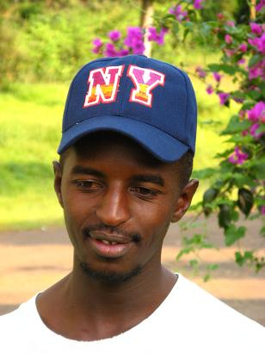
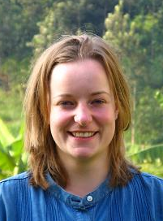
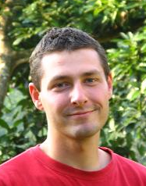
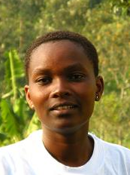
... the team

Nelson N. Muiru
Environmental Conservationist with KENVO, Kijabe in Kiambu District
P.O. Box 49-00221 MATATHIA
Tel.: 0722-909781
Email: nelliearts9406@yahoo.com

Genevieve Lamond

Student at University of Wales, Bangor, UK
School of environment and natural resources.
Tel.: 0736-035836
Email: genlamond@hotmail.com

Jean-Baptiste Leguet

Student in School of agronomy, Bordeaux, France
Tel.: 0736-434165
Email: jb.leguet@gmail.com

Martha Muthoni Njoroge

A clerk with DECI; agricultural researcher
P.O. Box 56 KANGEMA
Tel.: 0727-490474

what is icraf?
International Centre of Research in AgroForestry
Kituo cha kimataifa cha kufanya utafiti wa misitu na ukulima

what is cafnet?
Coffee AgroForestry Network
Kahawa na mazingira.
Objectives (Nia):
- To understand environmental benefits in coffee production
Kuelewa kuhusu mazingira na manufaa ya ukuzaji wa kahawa
- To strengthen access to information on coffee management.
Kuboresha ufahamisho wa ukuzaji wa kahawa.
Locations (Katika):
- East Africa
- Central America
- India
Duration (Wakati):
- Started in June 2007
- Whole program: 4 years
- Interviews: June to August 2007

Have some questions?
Please contact a member of the team with the contacts mentioned inside this brochure.

How to contact icraf
- Write to:
World Agroforestry Centre (ICRAF)
U. N. Avenue
PO Box 30677 | Nairobi | Kenya
- Phone: 254 2 524000
- Fax: 254 2 524001
- Email:
Dr J.M. Boffa: j.boffa@cgiar.org
Dr F. Pinard: f.pinard@cgiar.org

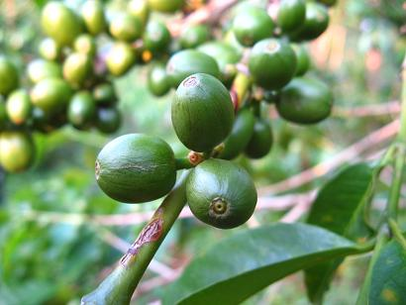
CAFNET is working in partnership with KENVO, CRF and CIRAD in East Africa.
Thank you for your participation, we look foreward to being in touch with you.


CAFNET Project

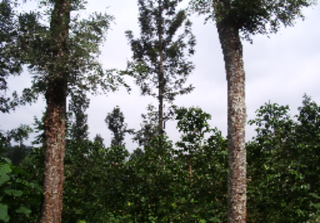

Kuunganisha,
kudumisha na kuimarisha uhusiano
kati ya
ubora na uuzaji wa kahawa
na
mazingira

